

|  |  |  |
| --- | --- | --- |
| **Module Code** | **:** | CT042-3-1-IDB – Introduction to Database |
| **Intake Code** | **:** | APDIF2206 |
| **Lecturer Name** | **:** | Lai Chew Ping |
| **Hand in Date** | **:** | 06 December 2022 |
| **Group No.** | **:** | Group 16 |
| **Group Leader** | **:** | Ng Shao Hwa |

|  |  |
| --- | --- |
| **Student ID** | **Student Name** |
| TP065019 | Ng Shao Hwa |
| TP068977 | Soong Yau Joe |
| TP068687 | Soo Jiun Guan |
| TP065322 | Adleena Binti Ahmad Nizam |

**Table of Contents**

Data Schema 4

Entity Relationship Diagram (ERD) 4

Database Diagram 5

SQL-Data Definition Language (DDL) 6

Tables and Query statements 6

Publisher 6

Book 7

Genre 8

Book Genre Bridge 9

Bookstore_Order 10

Book_BSOrder_Bridge 11

Member 12

Payment 13

Shopping_Cart 14

Member_order 15

Review 16

Rating 17

Member_order_detail 18

SQL-Data Manipulation Language (DML) 19

Student 1 (Adleena – TP065322) 19

Student 2 (Soo Jiun Guan – TP068687) 21

Student 3 (Ng Shao Hwa – TP065019) 23

Student 4 (Soong Yau Joe – TP068977) 25

Workload Matrix – Part 2 27

# Data Schema

## Diagram, engineering drawing Description automatically generatedEntity Relationship Diagram (ERD)

## Database Diagram

# SQL-Data Definition Language (DDL)

## Tables and Query statements

### Publisher

Query Statement:

Table:

### Book

Query Statement:

Table:

### Genre

Query Statement:

Table:

### Book Genre Bridge

Query Statement:

Table:

### Bookstore_Order

Query Statement:

Table:

### Book_BSOrder_Bridge

Query Statement:

Table:

### Member

Query Statement:

Table:

### Payment

Query Statement:

Table:

### Shopping_Cart

Query Statement:

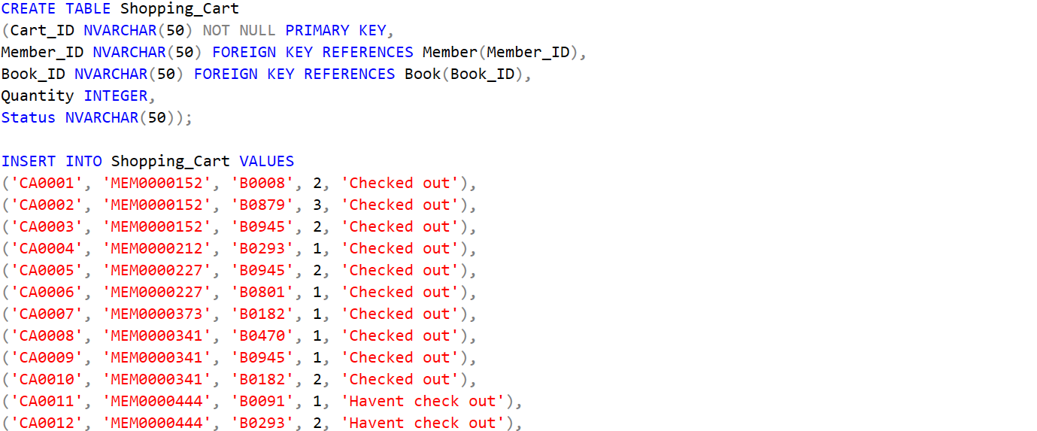

Table:

### Member_order

Query Statement:

Table:

### Review

Query Statement:

Table:

### Rating

Query Statement:

Table:

### Member_order_detail

Query Statement:

Table:

# SQL-Data Manipulation Language (DML)

## Student 1 (Adleena – TP065322)

i. Find the total number of books published by each publisher. Show publisher id, publisher name, and number of books published.

Query Statement:

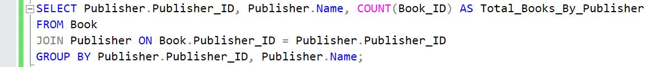

Result:

ii. Show the books in the shopping cart for each member which have not been check-out

Query Statement:

Result: 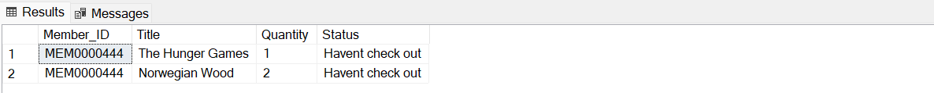

iii. List the book(s) which has the highest average rating. Show book id, book name, and the rating.

Query Statement:

Result:



## Student 2 (Soo Jiun Guan – TP068687)

iv. Find the total number of feedbacks per member. Show member id, member name, and total number of feedbacks per member.

Query Statement:

Result:

v. Find the publisher who published the most number of books.

Query Statement:

Result:

vi. Find the total number of books ordered by store manager from each publisher.

Query Statement:

Result:

## Student 3 (Ng Shao Hwa – TP065019)

vii. Find the genres of the book which has the most number of book quantity in stock.

Query Statement:

Result:

viii. Find the bestselling book(s).

Query Statement:

Result:

ix. Show the member(s) who spent most on buying books.

Query Statement:

Result:

## Student 4 (Soong Yau Joe – TP068977)

X. Show the members who had not make any order.

XI. A list of purchased books that have not been delivered to members.

XII. Show the members who made more than 2 orders.

# Workload Matrix – Part 2

